Radiocommunication Study Groups
Received: 1 June 2010 | Document 5D/749-E
 | 2 June 2010
English only

SPECTRUM ASPECTS
WiMAX Forum
input on ReVISION TO REcommendation ITU-R M.1036-3
Introduction
During its 7th meeting, ITU-R Working Party 5D continued to progress its work on a revision to Recommendation ITU-R M.1036-3. This document provides the views of the WiMAX Forum on certain aspects of this revision.
Flexible FDD/TDD
The WiMAX Forum notes that the flexible FDD/TDD band plan in Annex 5 is an important frequency arrangement that has already been implemented by some Administrations. The WiMAX Forum strongly supports this frequency arrangement and believes that option C3, “flexible FDD/TDD”, must continue to be shown in Annex 5. The current draft language in the vocabulary of terms (section 2bis) provides a useful definition of one possible flexible FDD/TDD approach. However, given that other permutations are also possible, further attempts to define a flexible FDD/TDD arrangement might lead to prolonged debate.
Mixing FDD and TDD
In the section 6, subheading “regarding technology aspects”, there are two options currently under consideration:
“Mixing TDD and FDD in a band may lead to a requirement for wider or more guard bands, and this may impact spectrum utilization; There are benefits from:
Option 1) leaving open the choice between TDD or FDD
Option 2) affording operators the choice of FDD and TDD technologies/duplex methods within a band
that could add value in terms of allowing the use of additional spectrum within the band, better accommodation of asymmetric traffic and allowing operators a wider choice of technology options to suit their needs”.
The WiMAX Forum supports option 2.

Traffic asymmetry implications
The current text regarding asymmetric traffic in section 7.2 is as follows:
“It is noted that traffic asymmetry can be accommodated by a variety of techniques including flexible timeslot allocation, different modulation formats, and different coding schemes for the uplink and downlink. With equal FDD pairing for uplink and downlink, or TDD, a degree of traffic asymmetry can be accommodated.”
The WiMAX Forum proposes the last sentence of the above paragraph be modified as follows:
“With symmetric FDD pairing for uplink and downlink, a degree of traffic asymmetry can be accommodated. TDD systems can accommodate a greater degree of asymmetric traffic.”
Text in each Annex
The most current working draft has included the following text in each Annex: “This Annex is part of Recommendation ITU-R M.1036 and the complete Recommendation should be considered in its entirety when implementing frequency arrangements.” and “Notwithstanding the recommended frequency arrangements, administrations may take any action (including the use of other combinations of FDD and/or TDD) to fulfil their requirements.”
The WiMAX Forum believes that the above two sentences together provide for sufficient clarity and thus supports inclusion of both sentences. Therefore, the WiMAX Forum supports removing the square brackets around the sentence “Notwithstanding the recommended frequency arrangements, administrations may take any action (including the use of other combinations of FDD and/or TDD) to fulfil their requirements.” in each of the Annexes.
Comments on Annex 6
The 3.4-3.6 GHz band has been one of the early focus areas of the WiMAX ecosystem, starting with fixed WiMAX and rapidly moving towards mobile WiMAX. Below is a summary of the WiMAX Forum profiles for the 3.4-3.6 GHz band.

Band Class Group | Uplink MS Transmit Frequency (MHz) | Downlink MS Receive Frequency (MHz) | Channel Bandwidth (MHz) | Duplex Mode
5L.A | 3 400-3 600 | 3 400-3 600 | 5 | TDD
5L.B | 3 400-3 600 | 3 400-3 600 | 7 | TDD
5L.C | 3 400-3 600 | 3 400-3 600 | 10 | TDD
5.D | 3 400-3 500 | 3 500-3 600 | 2x5, 2x7 and 2x10 | FDD

As a result of favourable regulatory conditions in certain parts of the world including Europe deployments of WiMAX in this band have increased considerably over the past few years. Following figure provide a snapshot of existing deployments of fixed (red pins) and mobile WiMAX (OFDMA TDD WMAN) (blue pins) in Europe.

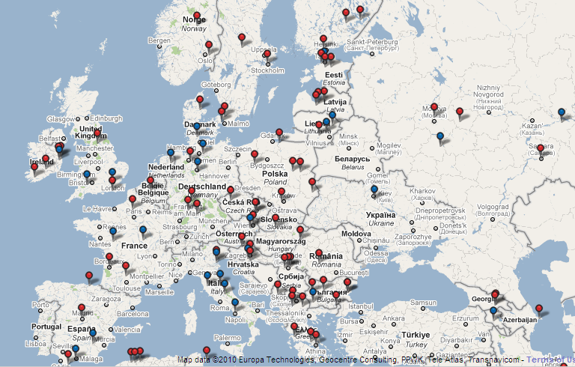

Supported by the European Communications Committee (ECC) Recommendation (04)05, followed by the European Commission (EC) Decision 2008/411/EC, which expanded the utilization of the band to include nomadic and mobile BWA systems, deployments of OFDMA TDD WMAN systems have already started in many European countries and are planned in some others. These deployments operate in spectrum allocated by the regulators that, despite some national variations, follow the WAPECS model as required by the EC. Specifically, in many of these deployments, the operators have been allowed, and have chosen to, deploy TDD systems in paired spectrum.
In order to embrace existing IMT-2000 deployments in the 3.4-3.6 GHz band and minimize any adverse impact on them, any frequency arrangement for this band should follow the following principles:
- Flexible use of the spectrum with technology and service neutrality – We draw attention to the following language from EC Decision 2008/411/EC:

The Commission has supported a more flexible use of spectrum in its Communication on ‘Rapid access to spectrum for wireless electronic communications services through more flexibility’ (2), which, inter alia, addresses the 3 400-3 800 MHz band. Technological neutrality and service

neutrality have been underlined by Member States in the Radio Spectrum Policy Group
(RSPG) opinion on Wireless Access Policy for Electronic Communications Services (WAPECS) of 23 November 2005 as important policy goals to achieve a more flexible use of spectrum.
And also to the following principle from ECC/REC/(04)05:
It is a requirement of the block assignment process, detailed in this recommendation, that systems supporting both symmetric and asymmetric traffic are accommodated as well as systems that employ FDD and TDD techniques.
- Block sizes, if any are specified, should be large enough to accommodate a variety of applications and to allow licensees to provide for broadband services. This is also supported by the ECC/REC/(04)05:

Medium-to-large size blocks (most likely of similar size between different operators) are anticipated and their size will depend, up to certain extent, on the applications foreseen. Administrations should be aware of the spectrum engineering measures proposed in the Annexes of this Recommendation and their relationship to the assigned block size. A key principle of the assignment guidelines is that even though a technology specific channelisation scheme is expected to operate within an assigned block, this channelisation is not the basis for the assignment process.
At the end, the WiMAX Forum reiterates its view as general principle that flexibility and technology neutrality must be fully incorporated by ITU-R when developing and recommending frequency arrangements for IMT bands.

_______________

ECC/REC/(04)05 – Guidelines for accommodation and assignment of multipoint fixed wireless systems in frequency bands 3.4-3.6 GHz and 3.6-3.8 GHz.
ECC Decision 2008/411/EC – On the harmonisation of the 3 400-3 800 MHz frequency band for terrestrial systems capable of providing electronic communications services in the Community.

